FM-PUF (FM Physical Unclonable Function) and AE-PUF (Ambient-Entropy Physical Unclonable Function):

Continuity‑Orchestrated Physical Identity
A Device–Environment Coupled Authentication Architecture with Motion Tethering, Runtime Continuity, Watermarking, and Excess Entropy
with Two Modes of Operation – 2-Way and 1-Way Communication
Date: 2026‑01‑14

Abstract
This paper presents a physics-anchored identity architecture based on FM-PUF (FM-band physical unclonable function) and its generalization, AE-PUF (ambient-entropy physical unclonable function). Rather than treating identity as a static secret or a one-time fingerprint, the system binds identity to a live device-environment coupled physical signature (DEC-PS) evaluated over time and summarized as a continuously updated trust state T(t).

We report an empirical FM receiver analysis on a small RSSI dataset to illustrate within-location stability, between-location separability, and rapid top-k saturation. Security claims are scoped to the economic infeasibility of sustained impersonation under verifier-controlled evaluation, not absolute unclonability.

Two operational modes are described. Mode A (Receiver-Only, 1-Way) supports self-verifying continuity when a persistent return channel is unavailable. Mode B (Bidirectional, 2-Way) supports interactive challenge-response and verifier-driven freshness. In both modes, motion tethering and Runtime Motion Tethering (RMT) (RMT) force an attacker to match live physical evolution rather than replaying a static recording.
Finally, we formalize excess entropy as the margin between a conservative entropy reserve allocated to primary security functions (authentication and key establishment) and the conservatively estimated extractable min-entropy produced by DEC-PS evidence under continuity scoring and fail-closed gating. This margin can be allocated to secondary assurances such as watermarking and provenance via domain-separated key derivations, without reducing the entropy reserve or security margin required for primary authentication.

Scope and Non-goals
This paper treats identity as a continuously evaluated physical process summarized by a verifier-side trust state T(t). The goal is to make sustained impersonation economically infeasible under verifier-controlled evaluation and continuity constraints.

Non-goals: the construction is not intended to remain valid under full device snapshotting, cloning, or virtualization where the attacker can perfectly reproduce the measured physical process. Likewise, one-shot replay of prior measurements is treated as an attack, and continuity mechanisms such as motion tethering and Runtime Motion Tethering (RMT) are used to detect and reject it.

Table of Contents

- Introduction

1.1 Filed Coverage Map and Modularity (Portfolio Framing)

1.2 Symbols and Definitions (Terminology Clarification - Identity vs. Authority vs. Session)

1.3 Architectural Overview

1.3.1 Operational Modes (Mode A (Receiver-Only, 1-Way) vs Mode B (Bidirectional, 2-Way))

1.4 FM‑PUF (Threat‑Model‑Grounded “Unclonability”)

1.5 AE‑PUF

1.6 Identity Regimes: LDPS vs DEC‑PS

1.6.1 Empirical FM‑PUF LDPS Analysis (RSSI; Single Receiver)

1.6.2 Dataset

1.6.3 Mean spectrum by location (Figure 1)

1.6.4 Within‑location stability and stable subvector (Figure 2)

1.6.5 Between‑location separability and top‑k scaling (Figure 3)

1.6.6 Distance distributions (margin intuition) (Figure 4)

1.7 Temporal variation is empirically benign on operational timescales
2. DEC‑PS: Device‑to‑device uniqueness (public RF evidence and modeling)
3. Receiver transfer‑function separability: public‑data sanity checks and conservative bounds
4. Practical takeaway for motion tethering
5. Bridging LDPS Empirics to DEC‑PS Feasibility Under Continuity
6. Empirical Scope and Limitations
7. Enrollment (Trusted Initialization)
8. Authentication: Device → Verifier

8.1 Authentication: Verifier → Device (Bidirectional Trust)
9. Motion Tethering and Runtime Motion Tethering (RMT)
10. Continuity Orchestration
11. Excess Entropy and Its Controlled Exploitation
12. AE‑PUF Watermarking and Provenance (Receiver‑only and Bidirectional)
13. Threat Model and Attack Economics
14. Limitations and Scope Clarification
15. Conclusion
16. Ethics and Privacy Considerations

1. Introduction
Digital identity systems overwhelmingly authenticate knowledge (passwords, private keys) or possession (tokens, certificates). These mechanisms commonly assume that secrets remain secret and that endpoints are difficult to emulate or proxy under realistic attacker capabilities. Both assumptions are increasingly fragile: secrets can be copied at scale, endpoints can be virtualized, and authentication exchanges can be proxied without physical presence.
Physical Unclonable Functions (PUFs) seek to re-anchor identity in the physical world. Certain intrinsic PUF designs rely on manufacturing variation, but they can be static, sensitive to environmental stress, and difficult to deploy at scale. More importantly, once enrolled, static physical fingerprints can still be replayed, modeled, or emulated if the adversary can sufficiently instrument the endpoint.
Ambient physical fields -RF, acoustic, thermal, mechanical - are continuously present, structured by geometry and motion, and evolve in time. They are observable, but not trivially reproducible on demand, particularly under policy-controlled timing, challenge selection, and motion constraints. This paper advances a physical identity model that treats identity as a runtime process, not a static attribute.
This architecture can operate as:
- a software-only capability on devices that already expose commodity ambient-sensing measurements through standard OS and radio APIs, subject to OEM/OS support for sampling access and timing control or
- an enhanced-hardware capability when stronger resiliency is required or when relevant ambient receivers are absent or inaccessible, for example by enabling additional measurement hooks in existing ICs or adding a small, dedicated sensing IC that provides FM and/or other ambient energy sensing and feature extraction. In particular, FM-PUF requires an FM-capable receive path that is exposed to the measurement software; where that path is not exposed on consumer devices, FM sensing can be provided through modest additional hardware or deeper platform integration

1.1 Filed Coverage Map and Modularity (Portfolio Framing)
The system described here is a portfolio of independently filed invention families that may be implemented separately or combined. References to combinations should be read as example architectures rather than requirements. The major filed families include (non-exhaustively) FM‑PUF, AE‑PUF, and Excess Entropy, together with portfolio elements such as continuity orchestration, motion tethering, run-time motion tethering, and watermarking/provenance.
A typical deployment composes these modules as follows: a verifier selects challenges and sampling schedules; the prover measures one or more physical anchors and derives a device–environment coupled physical signature; a continuity engine accumulates evidence over time and adjusts authentication confidence and re-challenge cadence; optionally, motion tethering constrains expected temporal evolution; optionally, excess entropy is budgeted for keying or post‑quantum reserve; optionally, watermarking binds capture-time measurements or derived artifacts to the session for provenance.
Unless explicitly stated in a particular embodiment, no single module is required. Continuity may be applied with or without motion tethering. AE‑PUF may be used with or without watermarking. Excess entropy budgeting may be applied with or without any specific cryptographic primitive.

1.2 Symbols and Definitions
Terminology Clarification — Identity vs. Authority vs. Session
This specification uses the term identity exclusively to refer to persistent physical distinctness of a device, established through live physical response coherence (e.g., FM‑PUF / AE‑PUF measurements) and evaluated probabilistically over time. Identity in this sense is not represented by cryptographic keys, certificates, or stored secrets, and is not replayable, transferable, or clonable.
Cryptographic mechanisms in this protocol are used only to establish verifier authority and session integrity, not device identity. In particular, cryptographic signatures authenticate that a verifier is authorized to issue challenges and is participating live in a specific protocol session; they do not assert or encode device identity.
Session binding (e.g., via nonces, timing constraints, and challenge parameters) establishes liveness and coherence for a single interaction and must not be interpreted as persistent identity. Authority, identity, and session are therefore treated as orthogonal concepts, each protected by different mechanisms and failure models.

Plane Mechanism Purpose
Verifier authority Cryptography (PKI / keys) Who is allowed to challenge
Session integrity Nonces, signatures Prevent replay / MITM
Device identity AE-PUF / FM-PUF Physical distinctness
Liveness & continuity Continuity orchestration Sustained trust
Provenance Excess entropy + receipts Auditability

Δt - Session Coherence Window: A bounded time interval during which physical measurements are assumed to remain mutually coherent. All session-bound protocol values are valid only within Δt.
E(t) - Ambient Entropy State: The vector of physical measurements sampled by a device at time t, including one or more ambient physical fields (e.g., RF, acoustic, thermal) and device-local sensing behavior.
F - Session Fingerprint: Transient, non-stored structural summary derived from the ambient entropy state E(t) over the session coherence window Δt. Fₛ represents relational and coherence properties of the device–environment interaction and is not a cryptographic key.
N - Nonce: A single-use value generated for a specific protocol instance to ensure freshness and prevent replay.
f(·) - Session-Binding Function: A one-way mixing function that combines the session fingerprint Fₛ, local device noise, and a freshness indicator to generate session-bound protocol values. The function is non-invertible and does not support reconstruction across sessions.
η - Local Device Noise: Device-internal non-deterministic noise sources (e.g., thermal noise, oscillator jitter, ADC noise) that contribute unpredictability and device individuality to session-bound values.
c - Freshness Indicator: A monotonic counter, secure timestamp, or sequence value used to guarantee ordering and prevent reuse of protocol values within or across sessions.
N = f (Fₛ, η, c) - Session-Bound Nonce Generation: The process by which a nonce is generated as a function of the current session fingerprint, local device noise, and freshness indicator, binding the nonce to the current physical session.
𝒞 - Current Physical Coherence Condition: The condition under which multiple independent physical measurements remain mutually consistent in timing, correlation, and short-term evolution over Δt, indicating a common device–environment origin.
V - Verifier: An entity that evaluates authentication evidence produced by a device. The verifier stores statistical models, acceptance thresholds, and policy parameters but does not store device-identifying secrets in a pure AE‑PUF architecture.
Kᵥ - Verifier Authority Key: A cryptographic key held by the verifier and used to authenticate verifier-originated protocol messages. Kᵥ is not device-specific and does not encode device identity.
T(t) - Trust State: A time-evolving state variable maintained by the verifier that represents confidence in device authenticity based on accumulated evidence across sessions. In practical deployments, the verifier can continuously expose T(t) (and a policy-mapped “trust level”) to the host device or platform within which the receiver is embedded (phone, vehicle ECU, gateway, IoT controller) so that runtime privileges can degrade gracefully when trust decays.
τ(t) - Trajectory Coherence State: A time-varying state variable representing confidence that the observed response sequence corresponds to a single physically plausible trajectory executed by the same physical device under live challenges.
Continuity Orchestration: A control process in which authentication is evaluated as a function of the evolving trust state T(t), integrating session-bound physical evidence over time and adapting verification parameters in response to observed conditions.
k - Subvector size (top‑k channels/features): The number of selected channels/features used for scoring in a given window.
δ, σ - Per-channel device-bias separation and residual noise standard deviation: Parameters used in conservative separability bounds.
Excess Entropy: The entropy remaining after reserving the most conservative requirement needed for post‑quantum cryptographic (PQC) security of primary authentication and key establishment, and after accounting for filtering, ECC/reconciliation, and helper-data leakage. By definition, “excess entropy” is optional and can be discarded without weakening PQC security margins.

1.3 Architectural Overview

1.3.1 Operational modes (Mode A (Receiver-Only, 1-Way) vs Mode B (Bidirectional, 2-Way)
This architecture supports two primary deployment modes. In both modes, an auditor/verifier uses a challenge-and-evidence schedule and evaluates a physical signature. The modes differ in whether the device only senses (receiver‑only) or also transmits an auditor-directed waveform (Bidirectional). Continuity orchestration and motion tethering can be applied to either mode.
Terminology note: in Receiver-Only (Mode A), a “challenge” refers to an internally generated measurement prescription or selector (timing, channels/bands, feature set, motion program), not an auditor-transmitted physical stimulus. In Bidirectional (Mode B), the challenge includes an externally directed physical waveform or actuation and the response is measured under that stimulus.

Mode A: Receiver-Only (1-Way, Self-Verifying)
In Receiver-Only deployments, the device is not merely a passive sensor. It operates as a self-verifying physical authority that generates measurement prescriptions, evaluates live physical coherence, and maintains a continuous trust state T(t) without requiring a persistent return channel.
Challenge generation may be internal (using on-device RNGs, stored challenge programs, and monotonic counters) and/or externally anchored (via public randomness beacons, transparency logs, or trusted timestamps). Under each challenge, the device performs live ambient-entropy sensing (e.g., FM broadcast RSSI spectra or other ambient physical fields), derives receiver-side observation vectors, and evaluates coherence against its expected stationary or motion-conditioned model. Evidence is accumulated over time, and T(t) is updated continuously to reflect sustained physical consistency or detected anomalies.
All challenges, responses, and trust-state updates are recorded in an append-only evidence chain, forming an auditable liveness transcript. This record enables later third-party verification of correct operation and physical presence without requiring continuous interaction with an external verifier during capture or execution.
In Mode A, authentication is therefore continuous rather than event-based: identity is earned over time through sustained physical coherence, represented by the evolving trust state T(t), which may be consumed directly by the host system (e.g., phone, vehicle, camera, build server) or inspected later by an external auditor.

Mode B: Bidirectional (active challenge–response)
In Bidirectional mode, the verifier issues an explicit physical challenge, and the device responds by transmitting and/or reflecting a waveform under verifier control. The verifier measures a response that depends on a device-associated physical process and the local environment, producing a device–environment coupled physical signature.
Examples include policy-controlled transmitted patterns that exercise RF impairments, channel responses, antenna interactions, or other analog effects. Compared to Receiver-Only mode, Bidirectional mode can increase controllability and bandwidth of the challenge space, at the cost of requiring an active transmit path and potentially tighter regulatory constraints depending on spectrum and power.

Threat model and implications. An attacker must emulate the challenged physical response under the internal or external verifier’s timing constraints while maintaining continuity over time. Proxying is possible in principle, but continuity and motion tethering are designed to make sustained success require persistent, low-latency, high-fidelity mediation.
Both modes can additionally provide provenance/deepfake identification by allocating excess entropy (strictly defined as beyond the most conservative PQC requirement) to watermarking keys and receipt chains, without weakening the primary PQC security budget.
In both operational modes, trust is represented by a continuously updated trust state T(t), which may be consumed by an external verifier or directly by the host system in which the device is embedded (e.g., phone, vehicle, camera, build server).

Related Work
Prior work relevant to AE‑PUF spans RF fingerprinting, channel and location-based authentication, continuous authentication, and the broader PUF literature. The key distinction in this paper is that we do not claim a one-shot, absolute unclonable fingerprint from either RF hardware quirks or ambient randomness alone. Instead, we scope security to the economic infeasibility of sustained impersonation under policy-controlled evaluation and continuity orchestration.
RF fingerprinting and device identification. A substantial literature uses RF impairments and waveform artifacts to identify devices, including modulation errors, IQ imbalance, carrier frequency offset, transient behavior, and learned feature extraction. These approaches often degrade under channel variation, mobility, and adversarial adaptation. AE‑PUF instead emphasizes device–environment coupling evaluated continuously and uses orchestration to increase attacker cost over time.
Channel and location fingerprinting. Physical-layer authentication also leverages propagation and channel features such as multipath structure and spatial decorrelation. Such methods derive security from the practical difficulty for an attacker to reproduce, at the verifier, the same channel response observed for the legitimate device—implicitly assuming limits on adversary co-location, relaying, and real-time channel synthesis.
AE-PUF. AE-PUF is related in spirit, but it operationalizes the dependence differently: the verifier does not merely compare a static channel “fingerprint,” it drives a live measurement process via verifier-chosen schedules and acceptance thresholds and scores sustained coherence over time. It also supports motion-tethered sessions, where changing measurement context becomes part of the evidence stream, raising the cost of replay, splicing, and proxying.
PUFs and modeling resistance. Classical intrinsic PUFs derive entropy from manufacturing variation and are evaluated via challenge–response pairs. Strong PUFs can be vulnerable to modeling attacks when many CRPs are observed, motivating anti-modeling structure and CRP rate-limiting. AE‑PUF differs in that entropy includes ambient variability and runtime coupling; it uses continuity as the primary defense against sustained emulation rather than claiming absolute unclonability of any single response.
Continuous authentication and liveness. Continuity orchestration aligns with continuous authentication ideas, sequential decision-making, and liveness checks. The distinguishing feature here is a policy-controlled evaluation loop over a device–environment coupled signature with fail-soft trust dynamics and an explicit economic security framing.

1.4 FM‑PUF (Threat‑Model‑Grounded “Unclonability”)
This document uses the term Physical Unclonable Function (PUF) in its standard engineering sense: a physical process that yields a device-associated response to a measurement challenge. As with other PUF families, unclonable here does not mean mathematically impossible to replicate under all conditions. Rather, clone resistance is understood under an explicit threat model and is achieved by making high-fidelity, low-latency emulation economically impractical at the required measurement bandwidth and timing, and by detecting continuity violations over time.
FM‑PUF derives a high-dimensional response vector from per-channel RSSI measurements across the FM broadcast band (87.9–107.9 MHz). At any location and time, the vector reflects transmitter geometry, multipath propagation, environmental scattering, antenna orientation and body loading, and receiver front-end behavior. FM‑PUF is an ambient physical fingerprint: the FM landscape is not secret, but it is structured, spatially variant, and time-evolving.

1.5 AE‑PUF
AE‑PUF generalizes FM‑PUF beyond FM radio to any ambient physical modality with repeatable behavior under refresh and non-trivial real-time reproduction cost. Examples include RF interference patterns, thermal microstructure, vibration and acoustic fields, power-supply noise, and electromagnetic emissions. AE‑PUF treats the device as a sensor of reality rather than a container of secrets.

1.6 Identity Regimes: LDPS vs DEC‑PS
To avoid conflating distinct security objects, we explicitly distinguish two operating regimes.

Landscape‑Derived Physical Signature (LDPS)
LDPS refers to structure inherent in the ambient physical environment itself, including spatial layout, multipath geometry, interference structure, and temporal evolution of naturally occurring fields. These environmental characteristics provide strong location and context binding and support liveness when sampled over time, but are not device-specific. Because the landscape is shared, LDPS alone does not establish device identity and is, in principle, vulnerable to sophisticated co-located re-radiation or relay attacks. “LDPS is about the world, not the device.”

Device–Environment Coupled Physical Signature (DEC‑PS)
DEC‑PS arises from the interaction between the ambient environment and a device-specific analog and temporal sensing transform, including front-end gain profiles, AGC dynamics, antenna coupling, nonlinearities, and sampling jitter. In DEC‑PS, identity is bound to how a particular physical device transforms the same environment, yielding responses that are internally coherent over time yet distinguishable across devices and continuously evaluable under live challenges and motion. The empirical FM‑PUF results in this paper establish LDPS feasibility. DEC‑PS feasibility is established from public analysis of RF device characteristics and is realized operationally through continuity orchestration and Runtime Motion Tethering (RMT). DEC‑PS is thus an emergent property of continuous evaluation rather than a property of any single response or snapshot measurement.
The empirical FM-PUF results presented in this paper illustrate the feasibility of LDPS under the measured conditions. DEC-PS feasibility is supported by public evidence that receiver measurement pipelines differ materially across nominally similar devices and by conservative separability bounds; DEC-PS is realized operationally through continuity orchestration and Runtime Motion Tethering (RMT), which convert device-specific sensing transforms into a continuously evaluable identity anchor.

Accordingly, the empirical results in Section 1.6.1–1.6.6 should be interpreted as validating the environmental (LDPS) component of the architecture. A device–environment coupled physical signature (DEC-PS) is instantiated whenever a device samples the ambient environment through its sensing chain, including on first observation. However, a single snapshot yields only a weak, non-exclusive identity signal. Device-specific identity strength emerges through continuous evaluation and policy-controlled orchestration, which bind the DEC-PS to time, motion, and verifier-defined challenges, suppressing replay and accidental equivalence.

1.6.1 Empirical FM‑PUF LDPS Analysis (RSSI; Single Receiver)
Established: repeatable behavior of the ambient FM landscape under policy-controlled refresh and challenge protocols; strong spatial separability with wide margins; existence of a stable subvector suitable for repeated evaluation; rapid accuracy saturation with small top‑k channel subsets.
Not established: resistance to unconstrained co-located RF injection; long-term environmental invariance. LDPS alone is not intended to provide resistance to co-located injection or long-term drift; these properties require identity to be bound to a specific device and evaluated over time, as formalized later in the architecture.

1.6.2 Dataset
We analyze a single-receiver FM RSSI dataset across five locations demonstrating stability, separability, and rapid top‑k saturation. A single FM receiver produced repeated full-band scans across 101 channels. Five locations were measured with 13–22 scans per location. Each scan is a 101‑D RSSI vector.

1.6.3 Mean spectrum by location
The mean RSSI spectrum varies by location in a structured way. (See figure 1)

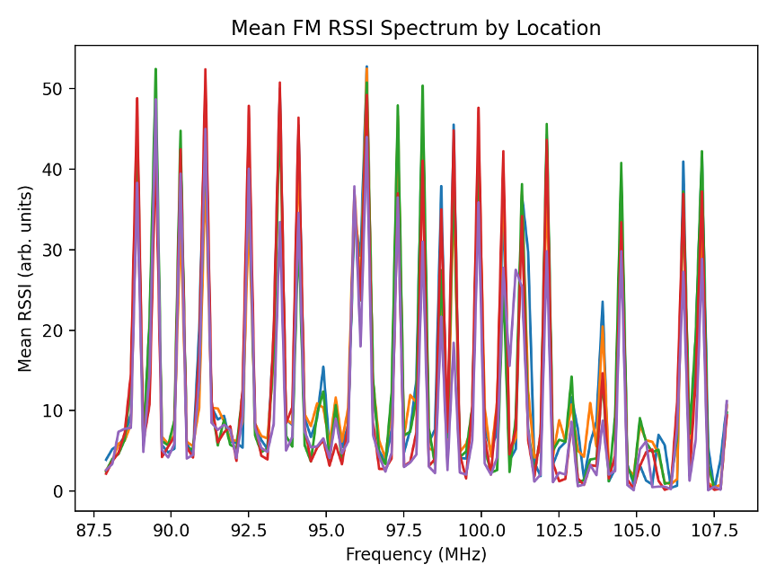

**Figure 1 (caption): Mean FM RSSI spectrum by location (five locations overlaid). Distinct spectral “shapes” and peak patterns support strong between-location separability.**

1.6.4 Within-location stability and stable subvector
For each location and channel, we compute the mean, standard deviation, and coefficient of variation (CV). Using a conservative strong-channel criterion, each location yields approximately 19–22 strong channels. The median CV among strong channels falls in the 0.016–0.047 range (depending on location), supporting reliable stable-sub vector operation. (See figure 2)

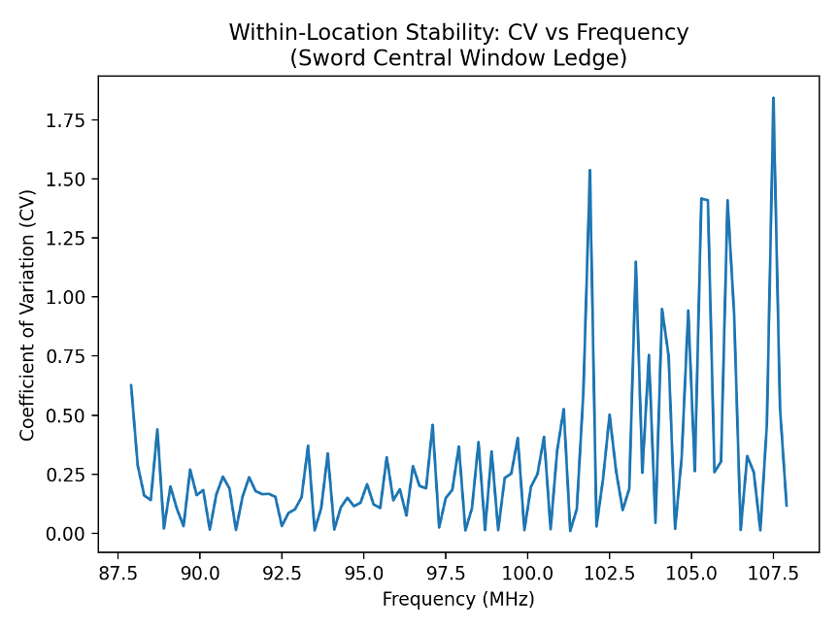

**Figure 2 (caption): Within-location stability: per-channel coefficient of variation (CV) across repeated scans at a representative location. A low-CV subset exists and motivates stable-subvector channel selection.**

1.6.5 Between-location separability and top-k scaling
We rank channels by discriminativeness (ANOVA F-statistic across locations), then evaluate nearest-centroid classification with leave-one-out cross-validation (LOOCV) using only the top-k channels. Accuracy saturates rapidly:
• k=1 yields ~0.94 accuracy,
• k=2 yields ~0.99 accuracy,
• k=11 yields 1.00 accuracy (first k reaching 100%). (See figure 3)

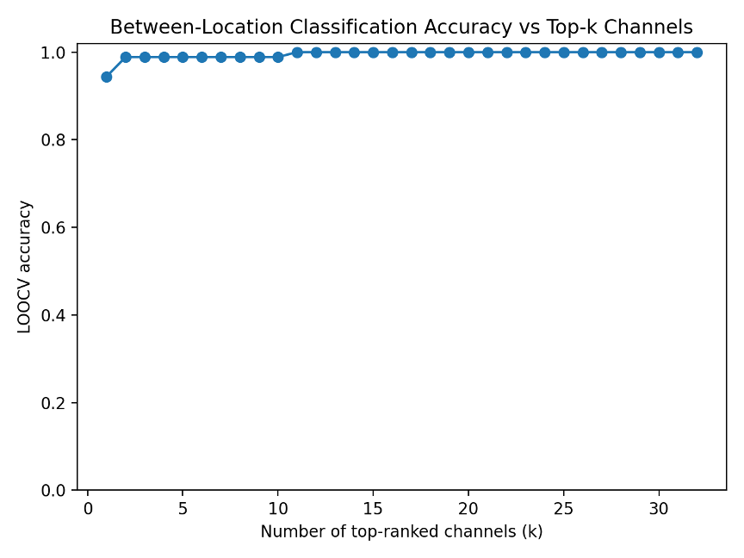

**Figure 3 (caption): LOOCV classification accuracy vs number of top-ranked channels (k). Accuracy saturates rapidly; 100% is achieved at k = 11 on this dataset; this figure is best interpreted as a dataset-specific operating point rather than a universal guarantee.**

1.6.6 Distance distributions (margin intuition
We compute the distance from each scan to its true location centroid (“intra”) and to the nearest other centroid (“nearest-other”) using k=11 channels. The distributions are strongly separated (mean intra ≈ 3.75; mean nearest-other ≈ 19.43), supporting robust thresholding under measured conditions.
Using LOOCV, we form a centroid for each location from all but one scan, rank channels with a Fisher score, and evaluate distances using the top‑k features. On this dataset (5 locations, 90 total scans, 101 channels), k = 11 yields a clean separation between sample-to-own-centroid distances (intra) and distances to the nearest other centroid (nearest-other). This separation supports threshold-based verification under the measured conditions (single receiver, fixed sites, limited temporal span) and should be treated as a dataset-specific operating point rather than a universal guarantee. (See figure 4)

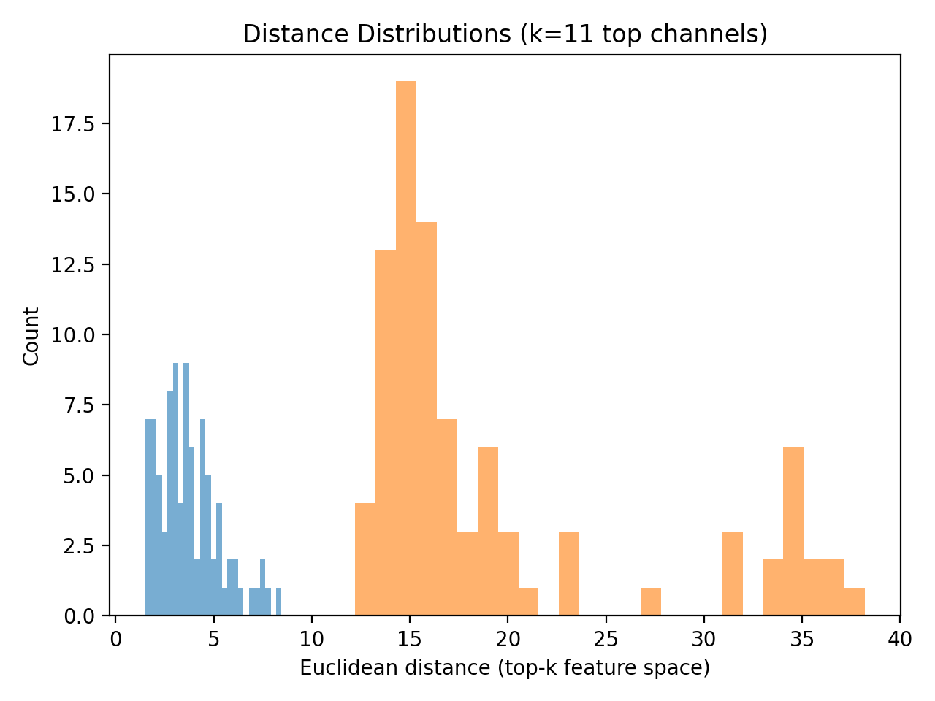

**Figure 4 Distance distributions (k=11): intra-location distances vs nearest-other centroid distances. Clear separation implies wide operating margins for threshold-based decisions.**

Data Availability
The underlying measurement dataset used to generate the analytic results and figures in this section is available to qualified reviewers and collaborators under a nondisclosure agreement, due to sensitivity related to device configurations and security implications.

1.7 Temporal variation is empirically benign on operational timescales
The dataset spans repeated scans over time at each location. Despite normal short-term variation (multipath microdynamics, transmitter fluctuations, incidental motion), stable subvectors exist and separability remains strong. Temporal variation over the measured timeframes validates FM‑PUF functionality over applicable operational refresh horizons.

2. DEC‑PS — Device-to-device uniqueness based on public RF performance data and analytical modeling
Physical-layer device fingerprinting leverages hardware-dependent impairments such as I/Q imbalance, non-linearity, and oscillator variation to distinguish radios, including among nominally identical devices. Prior surveys and datasets show these effects can be measurable and useful for classification in controlled settings, but the security properties depend on the attacker model and the ability to reproduce or emulate the relevant analog behavior.
Representative references (non-exhaustive):
• Danev, Zanetti, Capkun, “On Physical-Layer Identification of Wireless Devices,” ACM Computing Surveys, 2012.
• Polak, Dolatshahi, Goeckel, “Identifying Wireless Users via Transmitter Imperfections,” IEEE JSAC, 2011.
• Schenk, RF Imperfections in High-Rate Wireless Systems: Impact and Digital Compensation, Springer, 2008.
• Reising, Temple, Mendenhall, “Improving Intra-Cellular Security Using Air Monitoring,” IEEE TIFS, 2011.
• Merchant et al., “Deep Learning for RF Device Fingerprinting…,” IEEE JSTSP, 2018.

3. Receiver transfer-function separability: public-data sanity checks and conservative bounds (supports DEC‑PS for motion tethering)
Goal. Motion tethering and runtime continuity require that two nominally similar receivers observing the same evolving environment produce measurably different (yet individually self-consistent) response sequences - i.e., that device-specific sensing transforms (gain/AGC dynamics, frequency response ripple, nonlinearity, sampling jitter, antenna coupling) are separable enough to act as a stable identity anchor when evaluated over time.

3.1 Public evidence that receiver-side measurement transforms differ materially across devices
Multiple public lines of evidence show that receiver measurement pipelines are not standardized and can differ substantially device-to-device:
1) Large device-dependent RSSI offsets exist in practice (multi‑dB and in some reports tens of dB across devices).
2) Same-position device RSSI can differ by several dB (e.g., phone-to-phone BLE/RSSI differences).
3) RSSI is not guaranteed to be absolute power (dBm) and can be remapped per device (device-specific mapping and calibration behavior).
4) Receiver/capture-chain effects are large enough to confound fingerprinting unless explicitly addressed in multi-receiver datasets, reinforcing that receiver differences are first-class effects.
Collectively, these establish a conservative premise: receiver-side transfer functions vary by multiple dB in ways that are stable enough to require calibration in localization - and therefore are also usable as separable device-specific transforms when modeled explicitly for identity.

3.2 A conservative separability model for RSSI-vector AE‑PUF/FM‑PUF sensin
Let r_d(t) ∈ ℝ^K denote the measured RSSI vector for device d at time t, evaluated over a selected subset of K channels. We use the conservative additive model:
r_d(t) = a(t) + b_d + n_d(t)
where a(t) is the shared ambient landscape component (LDPS), b_d is the device-specific receive-chain transform (bias/shape term), and n_d(t) is residual noise after averaging/filtering over Δt.
For two devices d=1,2 exposed to the same a(t) (attacker-favorable), Δr(t)=r_1(t)−r_2(t)=(b_1−b_2)+(n_1−n_2). Separability reduces to whether (b_1−b_2) is large enough relative to residual noise.

3.3 Quantitative “minimum viable separability” bound (Gaussian, very conservative)
Assume (conservatively) per-channel residual noise σ ≈ 1 dB after short-window averaging, and assume device-specific bias difference per channel is only δ ≈ 2 dB (below common multi‑dB reports). For k ≈ 20 stable channels:
d_eff ≈ (δ·√k)/σ = (2·√20)/1 ≈ 8.94
A conservative confusion bound behaves like P_confuse ≈ Q(d_eff/2)=Q(4.47)≈3.9×10⁻⁶ for a single window. Runtime Motion Tethering (RMT) evaluates many windows, so sustained impersonation probability decays roughly exponentially with the number of independent windows. (confusion bound upper-bounds the probability that two distinct device–environment coupled physical processes are indistinguishable to the verifier under noise, quantization, and policy constraints; exact response collisions are a special case subsumed by this bound.)

3.4 Implication
Even minimal assumed receiver variability - well below what is publicly reported—becomes strongly separable when aggregated across a modest stable subvector and evaluated repeatedly over time under continuity orchestration.

4. Practical takeaway for motion tethering
• Public evidence indicates multi‑dB receiver-dependent measurement differences are commonplace.
• Even far smaller assumed differences (≈2 dB) become strongly separable when aggregated across a modest stable subvector and evaluated repeatedly over time.
• Therefore, commodity RF receivers plausibly provide sufficient separable transfer functions to support DEC‑PS-based motion tethering, provided the verifier uses stable‑subvector selection, short-window averaging/filtering, and multi-window continuity scoring.

5. Bridging LDPS Empirics to DEC‑PS Feasibility Under Continuity
The empirical FM‑PUF results establish the feasibility of LDPS: the ambient FM environment exhibits short-horizon repeatability, strong spatial separability, stable reliability-ranked subvectors, and rapid accuracy saturation under policy-controlled feature selection. These results intentionally avoid claiming intrinsic device uniqueness, as LDPS reflects properties of the environment rather than of the sensing device.
DEC‑PS arises when the same ambient landscape is observed through a device-specific analog and temporal sensing transform. The feasibility question for DEC‑PS - and for motion tethering in particular—is whether commodity receivers exhibit sufficiently distinct and stable transforms such that two devices exposed to the same evolving environment produce sequences that are internally coherent per device yet separable across devices under short windows.
This paper leverages public RF evidence and conservative bounds to support that premise. Under continuity orchestration, an adversary must reproduce not only the ambient landscape but the correct device-specific transformation as it evolves, with tight latency/coherence constraints. Publicly documented receiver variability is sufficient to make sustained impersonation economically infeasible at scale. No claim of absolute unclonability is required.

6. Empirical Scope and Limitations
Established: short-horizon repeatability and separability of FM‑PUF responses; existence of a stable, reliability-ranked subvector; rapid combinatorial scaling of the challenge–response space via subset selection; and device-to-device uniqueness support via public RF evidence and analytical modeling.
Not established: resistance to adversarial co-located signal injection and long-duration seasonal drift. These are system-level considerations addressed via orchestration and operational policy, and remain targets for expanded evaluation and future work.

6.1 Security Model and Claims
Entities. We define a prover device D and a verifier V. The prover device D is always the physical system under authentication and observes a device–environment coupled physical signature (DEC-PS), producing responses under a policy-controlled evaluation schedule.
In Bidirectional (Mode B) deployments, V is an external verifier that evaluates evidence produced by D and maintains a trust state T(t) that evolves with accumulated physical coherence rather than relying on a single-shot decision.
In Receiver-Only (Mode A) deployments, V is instantiated as a local verifier role on the device itself. The local verifier is a logically defined evaluation function that applies enrollment-defined models, measurement prescription schedules, and continuity-orchestration policies to update the trust state T(t) in a closed-loop manner.
In both modes, T(t) evolves continuously based on accumulated evidence and may be exposed to the host platform (e.g., phone OS, vehicle ECU, gateway) to gate privileges and enable graceful degradation when trust decays.
Adversary classes. We consider remote attackers who can relay, replay, or synthesize protocol messages; proximate attackers who can transmit signals near D or V; and co-located attackers who can attempt high-fidelity injection while matching the ambient field at the measurement location. We also consider partial compromise of D, including software compromise, while noting that a fully compromised measurement path is out of scope for physics-anchored authentication.
Assumptions. The verifier (external in Mode B or local in Mode A) controls evaluation cadence, windowing, and acceptance thresholds. Enrollment occurs under a trusted initialization procedure. The adversary is assumed unable to perfectly reproduce the same DEC-PS as evaluated by V across sustained time
Primary claim (economic, sustained). The core claim is economic infeasibility of sustained impersonation. Even if one window can be spoofed with some probability, continuity orchestration requires coherence across many windows under policy-controlled scheduling, and the probability of maintaining a forged trust trajectory decays rapidly with time under bounded-observability assumptions.

7. Enrollment (Trusted Initialization)
Enrollment binds a physical system to a verifier under controlled conditions and establishes the baseline models used for subsequent authentication. Enrollment does not establish a static identity token; it establishes statistical expectations for future, live interaction with the physical world. Enrollment establishes baseline statistical expectations for future continuous physical evaluation; identity is not asserted at enrollment but earned over time through coherence.
During enrollment, the verifier records:
• the permissible challenge space (frequency subsets, schedules, feature transforms, motion constraints);
• statistical model parameters (means, variances, covariance structure, deviation envelopes);
• reliability and quality metrics to weight channels/modalities during runtime orchestration.
The system explicitly does not store:
• replayable raw measurement vectors,
• static response values,
• long-term secrets derived from a single enrollment session.
Any helper data used for reconciliation or feature stabilization is constructed to minimize information leakage and is accounted for in the entropy budget (Section 11). Enrollment teaches the verifier how the physical system behaves, not what it will say.

8. Authentication: Continuous Physical Evaluation (Modes A and B)
Authentication in this architecture is not a discrete event, but a continuous physical evaluation process in which identity is earned over time through sustained physical coherence. Confidence is represented by a continuously updated trust state T(t), rather than by acceptance of any single response.
Depending on deployment mode, authentication may be evaluated either by an external verifier (Mode B) or locally by the device itself (Mode A). The verifier-authentication exchange described below applies only to Bidirectional (Mode B) deployments. In Receiver-Only (Mode A) operation, trust is derived from internally generated challenges and local continuity evaluation, without a live verifier exchange.

8.1 Authentication: Verifier Authority and Bidirectional Trust (Mode B)
Authentication may be evaluated either by an external verifier (Mode B) or locally by the device itself (Mode A); in both cases, identity is represented by the evolving trust state T(t), which is continuously updated and consumed either by an external verifier (Mode B) or directly by the host system for local policy enforcement (Mode A). When an external verifier is present, cryptographic mechanisms are used solely to establish verifier authority and session integrity, not device identity.
Bidirectional authentication (Mode B)
In Bidirectional (Mode B) deployments, the device authenticates the verifier before releasing sensitive functionality or evidence. Verifier authentication is performed by validating the verifier’s authority credentials (e.g., certificate chain or pinned public key) and checking freshness using a session-bound nonce.
Concretely, the device issues a device-generated nonce bound to the current physical session. The verifier responds with a signed, session-specific proof binding its identity, the device nonce, and the challenge parameters. The device verifies verifier authority, freshness, and session binding before releasing any responses for evaluation.
This ordering prevents response harvesting and simple replay attacks. A man-in-the-middle adversary may attempt real-time relay; however, continuity orchestration, timing constraints, and adaptive challenge scheduling make sustained relay economically impractical.
Receiver-Only operation (Mode A)
In Receiver-Only (Mode A) deployments, this verifier-authentication exchange is absent entirely during normal operation. The device instead relies on internally generated measurement prescriptions and local continuity evaluation to update its trust state in a closed-loop manner.T(t)
Although no live verifier exchange is required during operation, the device retains the ability to later prove liveness, continuity, and provenance through its append-only, auditable evidence chain and, where applicable, excess-entropy-derived watermarking.

9. Motion Tethering and Runtime Motion Tethering (RMT)

Motion Tethering
Motion tethering enforces anti-stasis by binding authentication to the evolution of physical measurements rather than a static snapshot. As a device moves, the ambient fields it senses evolve in correlated but not globally predictable ways.
Motion tethering enforces live coupling between:
- physical motion (inertial / RF / environmental change),
- ambient entropy evolution,
- device response coherence,
- and trust evaluation logic.

At each time step:
T(t+Δt)=U(T(t),E_motion (t),E_(AE"-" PUF) (t),E_timing (t))

Where:
- trust is stateful,
- no single measurement is decisive,
- and decay and recovery are explicit.

Motion tethering produces a continuously updated trust signal reflecting physical coherence during motion but does not itself prescribe device behavior.

Runtime Motion Tethering (RMT)
Runtime Motion Tethering (RMT) is a continuous identity enforcement mechanism built on motion tethering, in which a device’s security state is dynamically updated during motion, and device capabilities are gated in real time based on the evolving trust state T(t) derived from motion coherence, ambient entropy, and physical response continuity.
RMT couples trust evaluation to policy, enabling real-time restriction, degradation, or escalation of device privileges as physical coherence evolves.

10. Continuity Orchestration
Continuity orchestration is the control framework that maintains and updates a continuous trust state T(t), converting streams of noisy physical evidence into real-time authorization decisions rather than binary authentication outcomes. Trust is treated as a state variable T(t) that evolves in response to evidence, rather than a binary decision at a single instant. The verifier can expose T(t) to the host platform to drive graded behavior: allow, restrict, degrade, or quarantine.

10.1 Trust as a state variable
The verifier maintains a continuously updated trust score informed by multiple anchors:
• FM‑PUF / AE‑PUF response coherence,
• motion/trajectory coherence τ(t),
• timing/latency artifacts,
• device-specific sensing behavior,
• optional auxiliary modalities.
Each anchor contributes evidence; no single anchor must be perfect.

10.2 Operational attacker feasibility under continuity
Continuity changes the attacker objective from matching a single response to tracking a moving target under a policy-controlled schedule. Let the verifier evaluate W windows; if p bounds the attacker’s single-window spoof success, then sustained success scales no better than ~p^W under limited-correlation assumptions. The verifier can increase attacker cost by randomizing cadence, varying features, tightening thresholds after anomalies, and failing softly when observability is exceeded.

10.3 Orchestration control loop
Observe → Evaluate → Update → Adapt → Escalate/De-escalate.

10.4 Fail-soft behavior
When one modality degrades (RF interference, temporary motion pause), the system reduces weight on that anchor, increases reliance on others, increases refresh, and requests additional evidence rather than failing abruptly.

11. Excess Entropy and Its Controlled Exploitation

11.1 Definition of excess entropy (PQC-anchored, conservative)
Excess entropy is defined strictly as entropy capacity remaining after a policy-defined, conservative reservationsufficient to satisfy post-quantum cryptographic security margins. Only this excess entropy may be allocated to secondary functions such as provenance logging, watermarking, audit channels, or mesh authentication, ensuring that primary authentication security is never weakened. This definition is operational rather than statistical and does not assume uniformity or independence of the underlying entropy source.

11.2 Mapping to post-quantum security requirements
All provenance, watermarking, and audit mechanisms described in this work are derived exclusively from excess entropy and are cryptographically and operationally isolated from the entropy reserved for primary authentication.
AE-PUF is not a cryptographic algorithm; it supplies entropy to standard cryptographic constructions. For symmetric keys, the strongest known generic quantum attack provides roughly a quadratic speedup (Grover-style), so $b$ bits of classical entropy correspond conservatively to approximately $b/2$ bits of post-quantum security under widely accepted assumptions. Reserving 256 bits of classical entropy therefore yields approximately 128 bits of post-quantum security margin, consistent with conservative long-term security objectives often associated with Category-5–level strength, without implying formal certification or compliance.

11.3 Entropy budget illustration (conceptual)
Raw ambient entropy → after selection/filtering → after ECC and leakage accounting → entropy reserved for primary PQC security → excess entropy available for optional secondary functions.

11.4 Uses of excess entropy (without coupling to primary security)
Excess entropy may drive domain-separated watermark keys, provenance receipt chains, mesh or group authentication material, audit and control channels, or independent ephemeral session keys. Because excess entropy is defined only after conservative reservation for primary authentication is satisfied, these secondary uses do not weaken primary PQC security. Isolation is enforced both cryptographically (via domain separation and key derivation discipline) and operationally (via verifier-controlled entropy allocation and non-reuse across epochs).

12. AE-PUF Watermarking and Provenance
The mechanisms described here are used by both Mode A and Mode B deployments; in Mode A they are derived entirely from locally self-verified excess entropy. AE-PUF watermarking derives its keys exclusively from excess entropy, binding digital artifacts to physical origin and capture time without reducing the security margin reserved for primary authentication.

12.1 Deepfake resistance via capture-time watermarking
A capture device performs an AE-PUF session at capture time and derives a watermark key bound to the physical device (DEC-PS), the ambient environment, and the capture epoch. The device embeds a robust, invisible watermark into content or emits a signed receipt chain. Later verification checks that the watermark or receipts are consistent with an enrolled physical capture process.
Under the assumed threat model, offline or synthetic generation cannot mint valid watermarks or receipt chains without participating in the live, enrolled physical session, providing resistance to post-hoc fabrication and replay.

12.2 Provenance vs. authorship
AE-PUF watermarking establishes provenance (“originated from a live enrolled physical system at that time”), not authorship, semantic intent, or editorial responsibility.

12.3 Software supply-chain provenance
Build systems perform AE-PUF sessions during artifact generation and bind outputs to authorized physical build machines and build windows via watermarking or receipt chains, complementing conventional cryptographic signing with a physically anchored provenance layer. These watermarking mechanisms apply to both Bidirectional and Receiver-Only (Mode A) deployments, with Mode A provenance generated entirely from locally self-verified excess entropy under policy control.

13. Threat Model and Attack Economics
Security claims are scoped to attack economics under continuity orchestration, not theoretical impossibility.
Attacker classes:
1) remote attackers (no proximity),
2) relay attackers (proxy communications),
3) virtualized attackers (endpoint emulation),
4) co-located attackers (RF injection near device).

13.1 Why remote/relay/virtualized attacks fail
These attacks fail because the adversary cannot observe full physical state, predict verifier challenges, reproduce the device’s analog transfer function, or maintain temporal coherence under motion + challenge refresh. Even if a snapshot is replayed once, continuity detects incoherence across time and decays trust.

13.2 Co-located attacks and cost
A co-located attacker could attempt RF injection or wideband re-radiation. Sustained success typically involves low-latency, wideband synthesis aligned to randomized challenge schedules, modeling/matching device-specific transfer behavior, and maintaining coherence across motion and multi-anchor checks - expensive, detectable, and non-scalable.

13.3 Security claim restated
The system provides economic infeasibility of sustained impersonation under realistic orchestration policies, while remaining compatible with standard cryptography (including PQC).

14. Limitations and Scope Clarification
This study does not empirically characterize seasonal/multi-month drift. However, long-term drift is not required to be benign for correctness or security because authentication is evaluated over short, policy-controlled horizons. Slow drift affects baseline models and can be handled via controlled re-enrollment and model updates without storing replayable raw measurements. Future work includes multi-device studies, longer-horizon drift characterization, and adversarial RF injection experiments.

15. Conclusion
FM‑PUF and AE‑PUF, embedded in a continuity-orchestrated architecture with Runtime Motion Tethering (RMT), PQC-budgeted entropy, and optional watermarking/provenance, form a physics-anchored identity system that resists replay, relay, virtualization, and large-scale impersonation. Identity is not asserted once; it is continuously earned through interaction with reality.
Identity is not a claim. It is a process.

16. Ethics and Privacy Considerations
AE‑PUF is an identity and authentication primitive and therefore can be used in ways that implicate privacy. While the measurements discussed here do not contain user content, they can encode information about device linkage and location context over time. Deployments should incorporate consent, purpose limitation, bounded retention, and the ability to rotate or revoke derived identifiers. Where feasible, feature extraction and scoring should be performed on-device with only minimal decision statistics revealed to the verifier. Systems should be configured to minimize cross-context correlation and to avoid enabling covert tracking beyond the stated security objective.

