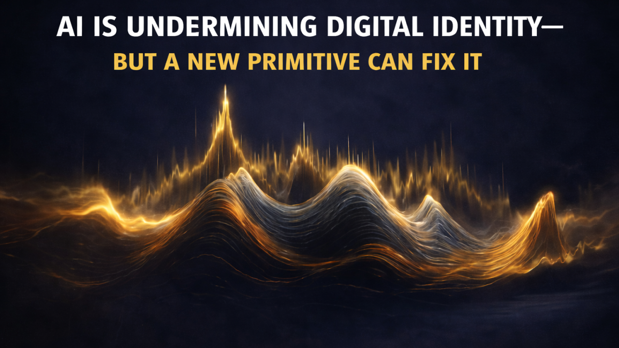

Digital Identity Is Failing — But a New Primitive Can Fix It

Rebuilding Digital Trust in the AI + Quantum Era | Physical Identity & Continuity Orchestration
January 6, 2026
For decades, digital security has relied on a quiet assumption: if we can protect cryptographic keys, signatures, and certificates, we can protect identity.
That assumption increasingly no longer holds — even when cryptography works exactly as designed.
AI has introduced a failure mode in which identity can be convincingly replayed without breaking encryption, forging signatures, or triggering alarms. In many modern systems, attackers no longer need to defeat cryptography at all. They simply operate inside it.
The result is a growing class of incidents where:
- credentials are valid
- MFA passes
- logs are clean
- provenance checks succeed
…and yet control has already been lost.
This is not a tooling failure. It is an architectural one.

Identity Authenticates Representations, Not Reality
Modern identity systems authenticate representations:
- keys and certificates
- tokens and assertions
- signed artifacts
- policy-compliant workflows
- behavioral models
- voice, face, and fingerprint representations
What they do not authenticate is reality.
Each of these signals exists entirely inside a digital abstraction layer. They can be copied, replayed, synthesized, proxied, or convincingly imitated — with increasing fidelity as AI capabilities improve.
Historically, this was acceptable because impersonation was expensive and brittle. To act as someone else, an attacker typically had to steal secrets, compromise hardware, or break cryptography — all noisy, high-risk activities.
AI changes that calculus.
AI increasingly makes it possible to replay identity — workflows, automation, timing, biometric likenesses, and trusted machine-to-machine behavior — while using perfectly valid cryptographic material. Nothing breaks. Everything verifies.
Trust appears to hold — until damage is discovered downstream.

How AI Enables These Failures
AI does not create new cryptographic weaknesses. Instead, it removes the friction that once constrained impersonation and replay. By learning system behavior, automating policy-compliant interactions, and adapting in real time, AI enables attackers to operate inside trusted identities at scale. The result is a class of failures where cryptography, policies, and provenance checks all succeed — and yet identity is no longer a reliable proxy for reality.

This Failure Mode Is Already Visible
This pattern is no longer theoretical. Variants of it are already visible across multiple domains:
- Software supply-chain compromises, where attackers operate inside trusted build systems and produce correctly signed artifacts without forging signatures or breaking cryptography.
- CI/CD and automation token abuse, where valid service identities are replayed to invoke authorized workflows that appear indistinguishable from legitimate activity.
- Session replay attacks that bypass MFA by reusing authenticated session state, even though authentication controls functioned as designed.
- AI-driven biometric impersonation, where voice or video likenesses successfully trigger legitimate authorization paths without tripping alarms.
- Cloud IAM “abuse of valid functionality,” where attackers use allowed roles, APIs, and policies exactly as intended.
In each case, cryptography works. Policies are followed. Audit logs look normal.
The common failure is not weak controls — it is the assumption that an identity representation remains accurate across time, context, and environment.

Why Software Supply Chains Are the Canary
Nowhere is this failure mode more consequential than in software supply chains.
Build systems, CI/CD pipelines, artifact repositories, and automated deployment frameworks are built on trust in authenticated builders, signed artifacts, and policy-constrained workflows.
These systems assume that if an artifact is signed correctly and produced by an authenticated process, it is legitimate.
AI erodes that assumption.
An attacker can impersonate build systems, replay trusted automation, or inject malicious artifacts that look procedurally correct — without tripping cryptographic, policy, behavioral, or biometric defenses.
The system verifies the representation of who signed the artifact, but not whether it was produced where and when it was supposed to be, how and by whom it was supposed to be, or whether the environment producing it remains legitimate right now — and therefore not whether that representation is accurate.
That is the gap.

The Missing Primitive: Physical Context
What current identity and provenance systems fundamentally lack is the ability to verify physical context over time.
They cannot reliably ask:
- Was it produced where and when it was supposed to be?
- Was it produced how and by whom it was supposed to be?
- Is the current physical operating environment consistent with its enrolled identity?
These are not philosophical questions. They are concrete verification gaps.
And they cannot be closed by adding more keys, more signatures, more policy, more behavioral analytics, or more biometrics — because all of those still live entirely inside the same digital abstraction layer that AI can increasingly inhabit.

The Solution: AE-PUF
AE-PUF (Ambient-Entropy Physical Unclonable Function) introduces a new identity and provenance primitive by anchoring trust to physical reality, not digital representation alone.
Instead of relying solely on cryptographic or representational signals, AE-PUF derives entropy from uncontrollable ambient physical signals present in the operating environment. These signals are:
- location-dependent
- specific device dependent
- time-varying
- difficult to synthesize remotely
- difficult to replay at scale
This allows systems to bind identity and provenance not just to who or what, but to where, when, and how a system is operating — continuously.

What AE-PUF Enables Systems to Verify
AE-PUF enables systems to verify three orthogonal properties that existing identity and provenance systems cannot reliably enforce:
- Was it produced where and when it was supposed to be?
- Was it produced how and by whom it was supposed to be?
- Is the current physical operating environment consistent with its enrolled identity?
These checks are evaluated at runtime, not just at enrollment.
Identity and provenance are no longer static claims that can be replayed indefinitely. They become continuously verified conditions.
Together, these checks bind trust to place, time, process, actor, and environment, rather than to static digital representations or metadata.

How This Changes Attack Economics
AE-PUF does not make attacks impossible. It makes them non-scalable.
To impersonate a system protected by AE-PUF, an attacker must reproduce the correct physical context, at the correct location and time, using the correct process and actor characteristics — continuously.
This sharply increases cost, reduces reliability, and limits scale.
The economics shift back in favor of the defender.

What AE-PUF Is — and Is Not
AE-PUF is:
- a new identity primitive
- a form of physical-context provenance
- complementary to cryptography and biometrics
- applicable to unattended, distributed, and automated systems
- especially relevant to software supply chains and origin verification
AE-PUF is not:
- a cryptographic algorithm
- a behavioral analytics system
- biometric authentication
- purely representational provenance (e.g., metadata-only or watermark-based schemes)
- a replacement for PKI or signatures
Cryptography still protects messages. Biometrics provide identity signals, but not reliable proof of identity under AI-driven replay. AE-PUF helps authenticate reality and origin.

How This Fits with Existing Supply-Chain Frameworks
AE-PUF does not replace frameworks such as SLSA, in-toto, or SBOMs.
Those frameworks record what an artifact claims about its origin and who is authorized. They do not verify whether those claims remain physically true over time.
AE-PUF strengthens these frameworks by adding a runtime physical-context constraint they were never designed to provide.
It is additive, not disruptive.

Why This Matters Now
AI has shifted identity and provenance failure from a corner case to a systemic risk. Continuing to add digital controls inside the same abstraction layer is increasingly insufficient for this class of attack.
What’s missing is not better math, models, or policies.
It is a missing constraint.
AE-PUF reintroduces physical reality into digital trust — something existing identity and provenance systems were never designed to do.
This is not the end of cryptography. It is the beginning of a move beyond crypto-only identity and provenance.

Closing Thought
Every major shift in security begins with recognizing a fading assumption and replacing it with a stronger primitive.
The assumption that identity and provenance can be secured purely through digital representations is becoming increasingly fragile.
The systems that adapt first will define the next era of trust

