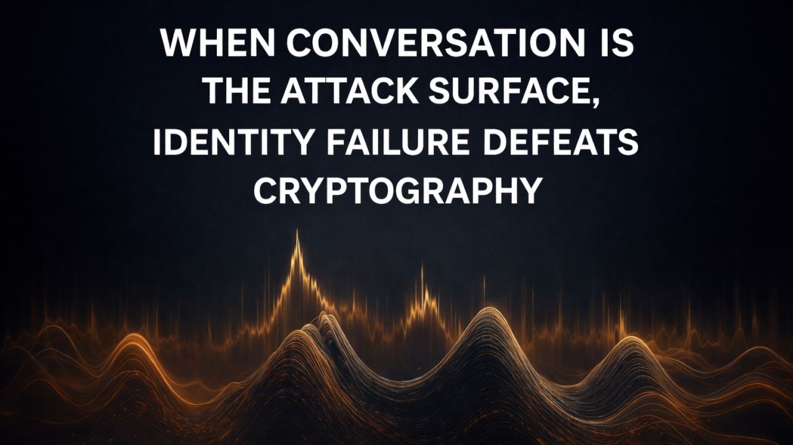

When Conversation Becomes the Attack Surface

Why identity must be anchored in physics, not symbols

Rebuilding Digital Trust in the AI + Quantum Era | Physical Identity & Continuity Orchestration
January 9, 2026
I recently learned-personally-how easily digital identity can fail, without any systems being hacked.
I received an email I believed was from my daughter. The address looked familiar, nearly identical to hers, differing only slightly. Nothing immediately raised concern.
I replied casually, asking what my grandson wanted for his birthday (by name) and passing along greetings to her husband.
“She” replied naturally, using both my grandson’s and son-in-law’s names correctly.
Over several exchanges, we discussed family matters and routine business topics. The conversation felt coherent, personal, and consistent. Nothing felt rushed or out of character.
Eventually, I sent a digital gift card for my grandson.
When “she” said it never arrived and asked me to resend it, I paused and verified verbally with my daughter. At that point, it became clear I had been communicating with an impersonator.
No accounts were hacked. No encryption was broken. No systems technically failed.
The failure was identity itself.

What actually went wrong
This was not a simple “cold” scam where the attacker arrived fully prepared.
The impersonation became convincing because the system allowed conversation before identity was established.
My first reply unintentionally supplied high-value relational data:
- my grandson’s name
- my son-in-law’s name
- confirmation of a real family relationship
- conversational tone and context
From there, the attacker adapted in real time.
Each exchange increased impersonation fidelity.
This is not identity theft in the traditional sense. It is interactive identity accretion - identity is learned, not stolen.
AI accelerates this dramatically. It doesn’t need full prior knowledge. It converges through dialogue.
The decisive failure point was not the gift card.
It was the first reply.

Why existing defenses don’t help
This attack bypassed:
- strong passwords
- multi-factor authentication
- cryptographic signatures
- email authentication (SPF / DMARC)
- user education
All of these protect accounts and messages.
None of them establish who is physically present on the other side of a conversation.
Symbolic identity - usernames, domains, keys - can always be imitated cheaply. AI makes that imitation believable at scale.
As long as systems allow interaction before identity is grounded, attackers can bootstrap trust socially.

The core insight
Conversation itself has become the attack surface.
As long as interaction is permitted first and identity is verified later - or never - impersonation is inevitable.
This is not a tooling problem.
It is an architectural one.

How AE-PUF changes the model
Ambient Entropy Physical Unclonable Functions (AE-PUFs) take a fundamentally different approach.
Instead of asking “Does this message look valid?” they ask “Is this identity physically continuous?”
AE-PUF binds identity to live physical reality, including:
- ambient RF and environmental entropy
- device-specific analog behavior
- temporal coherence
- optional motion and locality
Crucially, this identity is:
- not pre-stored
- not replayable
- not forgeable by AI
- not learnable through conversation

Continuity orchestration: the missing layer
AE-PUF systems treat trust as a state variable that must exist before interaction.
If a message arrives with:
- no prior continuity
- no physical coherence
- no enrolled trust state
then interaction itself is denied or escalated.
No reply. No conversation. No context leakage.
Without interaction, the attacker cannot learn names, relationships, or narrative detail.
The impersonation collapses at message zero.

Why this matters now
AI has shifted impersonation from:
- static forgery → adaptive convergence
- stolen identity → grown identity
- rare attacks → scalable attacks
Symbolic identity cannot survive this shift.
But physics still holds.
AI can generate language. It cannot fake being there.

The takeaway
The incident clarified something fundamental for me:
The attacker didn’t steal my daughter’s identity. They learned it because the system allowed conversation before identity was established.
AE-PUF eliminates that failure mode entirely - not by detecting fraud later, but by preventing trust from forming without physical presence.
Identity doesn’t need stronger math.
It needs a stronger anchor.

