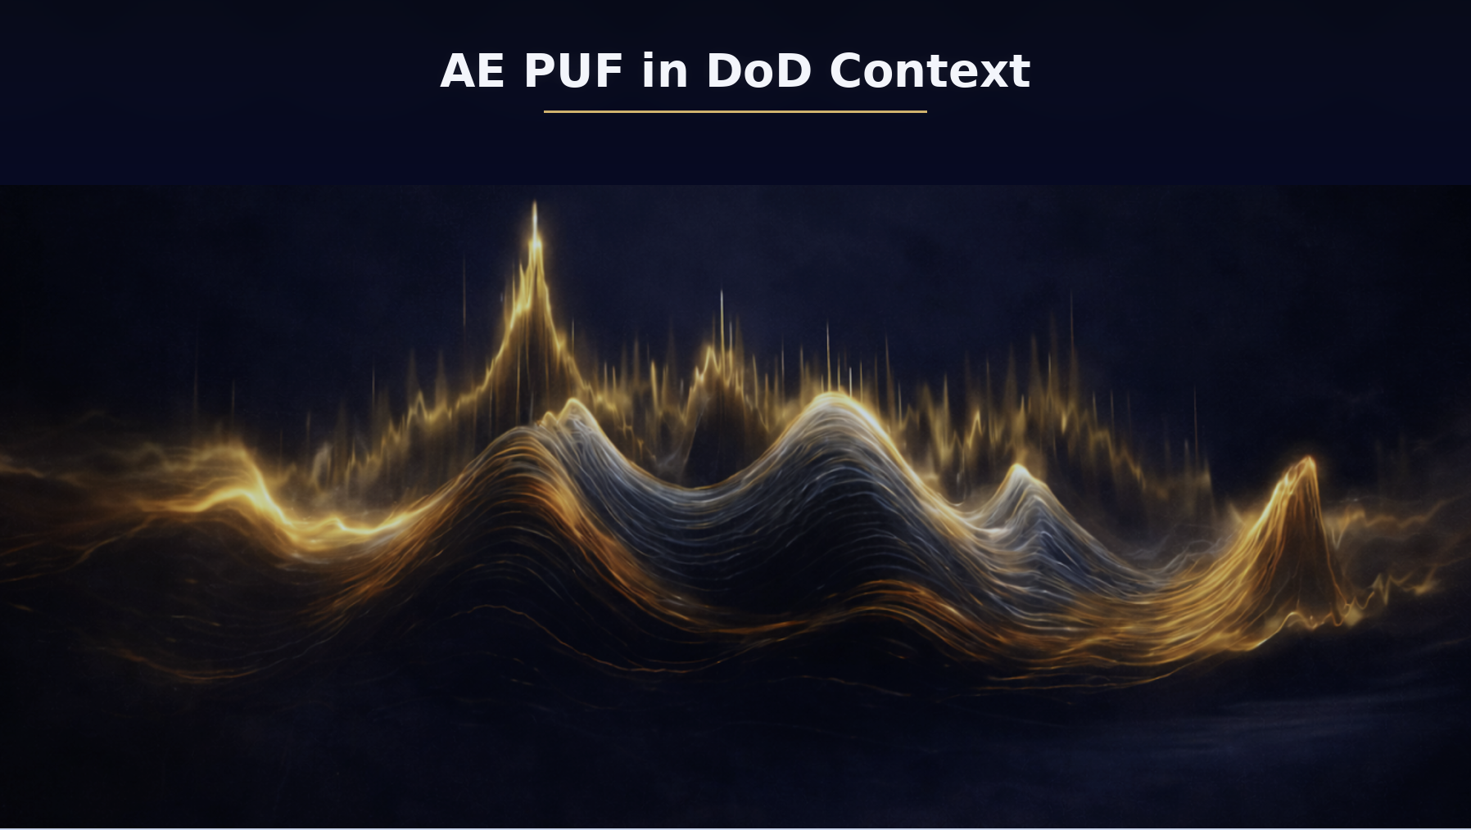

AE PUF in DoD Context
What current UAS security is optimized for
Most deployed drone security is optimized for controlling who can command the aircraft and what code runs on it.
Link security is the front line. You encrypt/authenticate C2 and payload links, manage keys, rotate sessions, and in military contexts add anti-jam, hopping, directional antennas, and low probability of intercept/detection features. This is excellent at preventing casual takeover and at protecting trAEfic confidentiality and integrity.
Platform security is the second line. Secure boot, signed firmware, anti-rollback, hardware-protected keys (TPM/HSM/secure elements), and sometimes remote attestation are used to stop persistent malware and protect long-lived credentials.
This stack mostly answers “is this endpoint authorized and running approved software” by proving possession of secrets and software state.

Where AE PUF is fundamentally different
AE PUF shifts the root question from “does this device possess the right key” to “can this physical instance produce a response that is hard to reproduce without being that instance.”
So rather than only relying on digital secrets, AE PUF tries to give you non-portable identity: even if someone copies firmware, clones storage, or emulates the protocol, they still can’t easily mimic the physical response characteristics tied to a device.
This is why AE PUF tends to be strongest as a supply-chain / anti-counterfeit / anti-clone primitive and as a second-factor root of trust for high-consequence actions.

Compare and contrast by security objective
Anti-takeover of command links
Traditional methods win on maturity and clarity. Standard crypto authentication on the link is a clean control. If keys are protected, takeover is hard.
AE PUF doesn’t replace link crypto; it complements it. Its value is mainly when you worry about scenarios where link credentials are stolen or a rogue endpoint is introduced. In that case AE PUF can add “even with keys, you still need to be an enrolled physical instance.”
Anti-clone and counterfeit hardware
This is where AE PUF stands out. Conventional security can uniquely identify a device with certificates, but if an attacker can extract keys (or if a manufacturing process leaks keys), identity becomes portable.
AE PUF aims to make identity non-extractable in a practical sense. Instead of guarding a static secret, you’re relying on a hard-to-replicate physical response. That’s a meaningful difference for drone supply chains because counterfeit modules and gray-market rebuilds are realistic threats.
Software supply chain and provenance
Planned and modern drone security is heading toward signed builds, SBOMs, provenance attestations, and “secure by design” pipelines. That’s the right direction, but it still leaves a gap: “this signed software is now running on… what, exactly?”
AE PUF can help bind provenance to the actual unit by supporting claims like “this image is running on this enrolled physical compute module,” which is useful for fleets, maintenance workflows, and sensitive capability unlocks.
Runtime compromise and post-exploit control
No honest framing says AE PUF magically defeats a fully compromised flight computer. If an attacker owns the endpoint, they may be able to suppress checks, lie about measurements, or gate when AE PUF is invoked.
The realistic advantage is defense-in-depth: AE PUF can make certain classes of impersonation and cloning harder, and it can support policy gating where high-risk actions require additional proofs. But it should be paired with measured boot, isolation (TEE), and strict key handling if you want meaningful protection post-compromise.
Relay and man-in-the-middle
Current systems generally don’t “solve relay” except by using standard cryptographic freshness and trusting the comm path. AE PUF doesn’t automatically solve relay either. You can make relay harder if your AE PUF usage ties acceptance to short-lived context and local sensing, but it’s best to describe AE PUF as raising cost and enabling better detection, not as a clean distance bound unless you explicitly add a ToF/distance-bounding primitive.
Jamming and denied environments
Traditional crypto systems don’t care about the RF environment beyond “can you communicate.” AE PUF can be more sensitive because it depends on stimulus quality. So AE PUF needs an explicit “degraded mode” story: what happens when the ambient field is weak, jammed, or the sensing chain is saturated?
That’s not a knock; it just means AE PUF is an additional layer that must be engineered like any sensor-dependent control.

How “planned” drone security stacks and AE PUF fit together
The most credible roadmap is not “replace everything with AE PUF.” It’s:
Secure boot + measured boot + remote attestation stays the core for software integrity.
Link crypto + COMSEC/TRANSEC practices stay the core for comm protection.
AE PUF becomes the physical-instance binding layer that strengthens anti-clone, maintenance provenance, and device legitimacy checks, and provides a higher assurance factor for sensitive actions like arming, BVLOS enablement, payload release, mission key loading, or joining a trusted swarm.

Existing and planned UAS security is primarily cryptographic and software-integrity centric. AE PUF adds a physics-anchored identity factor that is harder to clone and can bind provenance and authorization to a specific physical instance, at the cost of environmental dependence and the need for robust operational calibration and fallback modes.

